Breakfast
Banana muffins
Oat waffles with maple syrup
Crunchy apricot toast
Homemade muesli
Maple walnut granola
Spicy pumpkin pancakes
Zucchini and tofu scramble on toast

Lunch ideas
Chickpea and spinach with a sofrito of garlic and paprika
Warm new potato and asparagus salad
Grilled tofu steak salad with soy sauce, sesame and ginger
Grilled vegetables with basil oil
Sweet barley, radicchio and rocket salad
Broccoli, beetroot, pear and dandelion salad
Cannellini beans with garlic and parsley
Pardina lentil salad with cashew, chilli and orange
Freekeh salad with bulgur wheat, preserved lemon, cumin and mint
Chilli runner beans stir-fried
Penne pasta with roasted red pepper pesto
Lebanese tabouleh with spring onion, mint and cinnamon
Cauliflower and white radish pickle
Guacamole salad with chilli beans
Tomato, olive and spring onion couscous
Fusilli with parsley and pistachio
Vegan quiche with tofu, garlic, tomato and basil
Coca de trampo, mallorquin slice with tomato, pepper and onion
Sautéed Swiss chard with garlic

Dinners
Cauliflower and carrot terrine
Stuffed marrow rings with onion and almond
Chocolate tahini fudge

Butternut squash soup
Chestnut and wild mushroom farinata
Blood oranges in rosemary pepper syrup

Tom yum vegetable soup
Green thai vegetable curry
Thai fruit salad

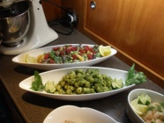
Mango and avocado salad with chilli vinaigrette
Chickpea stew with lemon and spinach
Cranachan with soya cream, raspberry and whisky

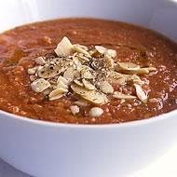
Chilled tomato soup with almond and garlic
Stuffed savoy leaves with tomato and chilli risotto
Gluten free vegan chocolate cake

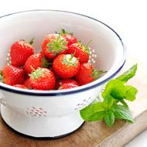
Fresh ceps with chilli and garlic
Sweet and sour aubergine
Strawberries and basil in hot syrup

Avocado stuffed with tomato and coriander salsa
Tofu, broccoli and cashew stir-fry
Cherry torte

